**National University of Computer & Emerging Sciences**

**Karachi Campus**



**Software Engineering and Economics**

**Project Report**

**Prepared by:**

**Taha Jawaid (21K-3881)**

1. (LOC) Calculation Hypothetical

Functionalities with Estimated LOC

1. User Authentication: 300 lines
2. User Management: 400 lines
3. Content sharing: 500 lines
4. Communication: 300 lines
5. User Analytic and feedback: 200 lines
6. Database interaction:600 lines
7. Multimedia Capabilities: 300 lines.
8. User Interface: 400 lines
9. System Configuration: 300 lines

**Code Complexity:** Moderate  
**Language:** DART

Total Loc: 300+400+500+300+200+600+300+400+300 = 3300 Lines

1. (LOC) Calculation After Applying Adjustment Factor

**Adjustment:** Buffer Lines for error handling, logging. Let’s add 25% as a buffer.

25/100*3300 = 825

Adjusted LOC: 3300+825 = 4125 LOC.

1. Loc calculation using Functional Points:
2. External Inputs (EIs) = 7 (3 Average, 4 Complex)
3. External Outputs (EO) = 3 (1 Simple, 2 Average)
4. External Enquires (EQ) =2 (1 simple, 1 Average)
5. Internal Logical Files (ILF) = 4 (3 Average, 1 complex)
6. External Interfere Files (EIF) = 3 (1 Average, 2 Complex)

|  |  |  |  |  |  |
| --- | --- | --- | --- | --- | --- |
| Functional Units | count | Weighting Factors | | | Calculated |
| External Inputs (EIs) External Outputs (EO) External Enquires (EQ) Internal Logic Files (ILF)  External Interfere files (EIF) | 7  3  2  4  3 | Simple | Average | High | 36  14  7  45  27 |
| 3  4  3  7  5 | 4  5  4  10  7 | 6  7  6  15  10 |

Count Total = 36+14+7+45+27  
  
Count Total = 129

Functional Point = CT * [ 0.65 + (0.01 * ∑Fi)]  
Adjustment Factor (fi) = 14

Adjustment Factor:

Moderate (5)

Average (7)

Essential (2)

∑Fi = [ (5*2) + (7* 3) + (2* 5)] = 41

FP = (CT * [(0.65) + (0.01 * ∑Fi)]  
FP = [129 * 0.65 + (0.01 * 41)]

FP = 136.74  
FP = 137

Language = DART  
One FP Translate 55 LOC  
137 FP = 137 * 55 = 7535 LOC

**Using three Points Estimates to calculates Final LOC**

1. Optimistic: 3300 LOC
2. Most Likely: 4125 LOC
3. Pessimistic: 7535 LOC

Estimated LOC: (O + 4M + P) / 6  
= (3300 + 4(4125) + 7535) / 6  
= 4555.83

= 4556

=4556/1000

= 4.556

=4.6k

**Estimated KLOC = 4.6 KLOC**

Constructive Cost Model (COCOMO)

|  |  |
| --- | --- |
| LEVELS | Modes |
| Basic  Intermediate  Detailed | Organic (2K – 50K LOC)  Semi-Detached (50K -300 K LOC)  Embedded (>300 KLOC) |

**Model Table**

|  |  |  |  |  |
| --- | --- | --- | --- | --- |
| Model | A | B | C | D |
| Organic  Semi-Detached  embedded | 2.4  3.0  3.6 | 1.05  1.12  1.20 | 2.5  2.5  2.5 | 0.38  0.35  0.32 |

Basic COCOMO:

KLOC = 4.6 (Organic)

**Effort:**

E = a* (KLOC)b  
E = (2.4) * (4.6)1.05  
E = 11.92  
E = 12 p-m

**Time Of Development:**

TDev = C * Ed

TDev = (2.5) * (12)0.38

TDev = 6.427

TDev = 6M

**Staff Size:**

Staff Size = E/TDev

Staff Size = 12/6

Staff Size = 2 Persons

**Productivity Rate:**  
Productivity Rate= size/efforts

Productivity Rate= 4600/12  
Productivity Rate= 383.33  
Productivity Rate = 383 LOC/p-m

Intermediate COCOMO:

E = a*(KLOC)b * c

Cost Drivers =15

|  |  |
| --- | --- |
| 1. Rely = 1.15 2. Data = 0.94 3. Complex = 1.15 4. Time = 1.11 5. Storage = 1.06 6. Viral = 1.15 7. Turn = 0.87 | 1. ACAP = 0.86 2. AEXP = 0.91 3. PCAP = 0.86 4. VEXP = 0.90 5. LEXP = 0.95 6. MODP = 0.91 7. TOOL = 0.91 8. SECD = 1.04 |

C = 0.725

Effort:

E = a * (KLOC)b * C  
E = 11.92 * 0.7  
E = 8.344  
E = 8 p-m

**Time Of Development:**

TDev = c * Ed

TDev = 2.5 * 80.38

TDev = 5.5 M

TDev = 6 M

**Staff Size:**

Staff Size = E/TDev

Staff Size = 8/6  
Staff Size = 1.33 person.

Staff Size = 1 person

**Productivity:**

Productivity = size / efforts  
Productivity = 4600 / 8  
Productivity = 575 Loc / p-m

Detailed COCOMO:

KLOC = 4.6 (Organic Small) 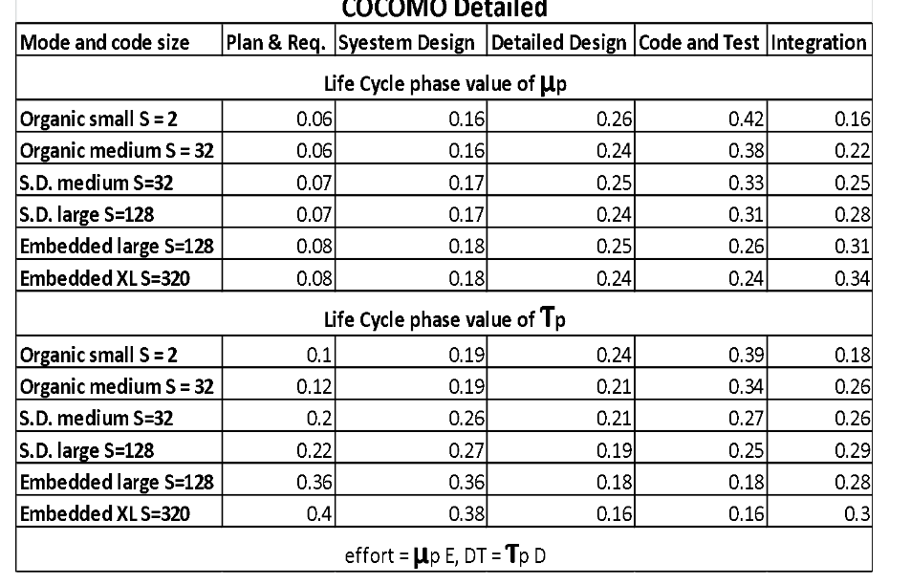

**Effort:**

**Ed = UD * Ei  
Ei = 8p-m**

* Planning and Requirement:  
  Ed = 0.06 * 8  
  Ed = 0.48
* System Design:  
  Ed = 0.16 * 8  
  Ed = 1.28
* Detailed Design:  
  Ed = 0.26 * 8  
  Ed = 2.08
* Code and Test:  
  Ed = 0.42 * 8  
  Ed = 3.36
* Integration:  
  Ed = 0.16 * 8  
  Ed = 1.28

ΣEd = 0.48 + 1.28 + 2.08 + 3.36 + 1.28   
ΣEd = 8.48  
ΣEd = 9 p-m

**Time Of Development:**

Td = Tp * Tdevi   
Kloc = 4.6 (Organic small)  
 Tdevi = 6

* Planning and Requirement:  
  Td = 0.1 * 6  
  Td = 0.6
* System Design:  
  Td = 0.19 * 6  
  Td = 1.14
* Detailed Design:  
  Td = 0.24 * 6  
  Td = 1.44
* Code and Test:  
  Td = 0.39 * 6  
  Td = 2.34
* Integration:  
  Td = 0.18 * 6  
  Td = 1.08

ΣTd = 0.6 + 1.14 + 1.44 + 2.34 + 1.08  
ΣTd = 6.6  
ΣTd = 7M

**Staff Size:**

Staff-Size: Ed/ ΣTd  
Staff-Size: 9/7  
Staff-Size: 1.28  
Staff-Size: 1 person

**Productivity:**

Productivity rate: size / efforts  
Productivity rate: 4600 / 9  
Productivity rate: 511 LOC / p-m

**Cocomo 2:**

Application Composition Model

Step # 1

1. 11 screens [ 4 views (2 server, 2 client)]
2. 6 data tables
3. 2 Reports [2 Sections (1 server, 1client)]
4. 25% reusable

Step # 2

Screen: Medium Weight(2)

Report: Simple Weight(2)

Step # 3

* Object point: Σ (Object * W)  
  Object point: (11 * 2) + (2 * 2)  
  Object point: 22 + 4  
  Object point: 26

Step # 4

* New Object point: OP * (100 - %reuse)/100)  
  New Object point: 26 * (100 - 25) / 100  
  New Object point: 19.50  
  New Object point: 20

Step # 5

* Productivity Nominal: 13

Step # 6

* Efforts: NOP/PROD  
  Efforts: 20/13  
  Efforts: 1.53  
  Efforts: 2 p-m

Step # 7

TDev = c * Ed

TDev = 2.5 * 20.38

TDev = 3.25 M

TDev = 3 M

Step # 8

* Staff-Size: E/Td  
  Staff-Size:2/3  
  Staff-Size: 0.67  
  Staff-Size: 1 person

Step # 9

* Productivity Rate: Size / efforts  
  Productivity Rate: 4600 / 2  
  Productivity Rate: 2300 LOC/ p-m

Early Design Model

PMnominal = A * sizeb * M  
A= 2.5  
b = 0.91 + 0.01 * (sum of rating scale)

Sum of rating scale = PERC + RESL + FLEX + TEAM cohesion + Process Maturity

1. PERC - High – 3.72
2. Development Flexibility - Average – 2.83
3. RESL - Low – 2.03
4. Team Cohesion - High - 2.19
5. Process Maturity - High - 3.12

Sum of Rating = 3.72 + 2.38 + 2.03 + 2.19 + 3.12 = 13.44

b = 0.91+ 0.01*(13.44)

b= 0.91 + 0.1344

b= 1.04

PMnominal = (2.5) * (4.6)1.04 * M  
M = 17 cost drivers  
M = 3.1

PMnominal = (2.5) * (4.6)1.04 * 3.1  
PMnominal = 37.89

PMnominal = 38 p-m

TDev = [(3.0) * (38) ^0.33 +0.2 (1.04 -0.99)] *SCEP/100  
SCEP = 100% normal  
TDev = 10.33  
TDev = 10 M

Reuse Model

AA: Some Module Test and Doc- 4

SU: Very High - 10

UNFM: Some what Familiar - 0.2

BM: 20%

CM: 30%  
IM: 10%  
AT: 30%  
LOC: 4600

AAF = (0.4 * BM) + (0.31 * CM) + (0.3 * IM) + (0.4 * 20) + (0.3 * 30) + (0.3 * 10)

AAF = 20  
AAM= AA + AAF *(1 +(0.02 * SU * UNF) / 100

AAM= 4 + 20 *(1 +(0.02 * 10+ 0.4) / 100

AAM: 36 / 100

AAM = 0.36

New LOC = Adopted LOC * (1 - AT/100) * AAM  
New LOC = 4600 * (1-30/100) * 0.36  
New LOC = 1159.2  
New LOC = 1159 LOC

Post Architecture Model

PMadjusted = PMnominal * Emi

Emi = 17 Cost Driver in Post Architecture

Emi = 1.6

PMnominal = 38 p-m

PMadjusted = 38 * 1.6

PMadjusted = 60.8

TDev = [(3.67) * (PM) ^0.28 +0.2 (B -0.99)] *SCEP/100

B = 1.04

SCEP = 100% normal

TDev = [(3.67) * (38) ^0.28 +0.2 (1.04 -0.99)] *SCEP/100

TDev = 10.643

TDev = 11 M

Cosysmo Model

PMnominal = A *size * EAF

A = 28

Size = 4.6

EAF = 1*1*1*1*1*1*1*1*1*1*1*0.81*1.23*0.81=

PMnominal = (28) * (4.6) * (0.8070)

PMnominal = 103.9416  
PMnominal = 104 p-m

**Story Point Estimation Technique**

1.**User Authentication:** Implementing User authentication involve to register sign up, log in, and authentication checks and maintain account records. Given the need for encryption, validation, and integration, this might be a moderately complex task. Let's assign it 5 story points.

2.**Content Posting:** This feature requires allowing users to create posts with multimedia content, implementing storage and retrieval mechanisms for posts, and ensuring text descriptions accompany multimedia uploads. Considering the need for handling different types of data and storage operations, let's assign it 8 story points.

3.**Profile Management:** This involves creating, updating, and displaying user profiles, including profile pictures, personal information, and customization options. Given the CRUD operations and UI interactions involved, let's assign it 3 story points.

4.**Search and Filtering:** This feature requires implementing search functionality and filtering options based on user input, categories, or tags. Considering the need for data retrieval and manipulation, let's assign it 4 story points.

Total Story Point for Social Hub = 5+8+3+4 =20

**Line Of Code Comparison Graph:**

After a comprehensive evaluation of different estimation methodologies for our Socialize Hub project, we have reached significant conclusions. The hypothetical technique suggested a codebase of 3300 lines of code (LOC), while the functional points approach estimated 7535 LOC. Utilizing the three-point estimation method, we arrived at a figure of 4555 LOC for our subsequent planning. By carefully considering the merits and demerits of each technique, we have synthesized a comprehensive perspective to steer our development process effectively. This holistic approach ensures that our estimations are robust, providing a sturdy groundwork for the successful execution of the Socialize Hub project.

**Effort Comparison Graph:**

In reviewing our effort calculation techniques for the project, we've uncovered a range of estimates across various methodologies. Basic COCOMO, despite indicating a lower estimate previously, now suggests an effort of 12, while Intermediate COCOMO estimates 8. Detailed COCOMO provides a slightly higher estimate at 9. The Application Composition Model maintains its position with the lowest estimate at 2. However, the Early Design Model presents a significantly higher effort projection of 38, indicating potential complexities or oversights in early-stage planning. Additionally, Planning Poker suggests an effort of 12. These diverse estimations underscore the importance of thorough analysis and consideration of project intricacies. Moving forward, we'll integrate these insights into our planning processes to ensure a more accurate and robust effort estimation framework.

**Development Time Comparison Graph:**

Following an extensive assessment of different development time calculation techniques for our project, we have synthesized valuable insights. Both Basic COCOMO and Intermediate COCOMO methodologies converge on a development time estimate of 6 months. Detailed COCOMO extends this timeframe slightly, predicting a duration of 7 months. In contrast, the Application Composition Model suggests a significantly shorter development time, assessed at 3 months. Conversely, the Early Design Model forecasts a longer development period, spanning 11 months. By carefully weighing the strengths and limitations of each approach, we have formulated a comprehensive understanding to guide our project scheduling effectively. This holistic approach ensures that our development timeline is robust, facilitating informed decision-making throughout the project lifecycle.

**Conclusion**

In conclusion, our comprehensive analysis of various estimation and calculation techniques has provided invaluable insights for guiding our project planning and execution. Across different methodologies, such as lines of code estimation, effort calculation, and development time projection, we've encountered diverse perspectives and estimations. While certain techniques, like Basic COCOMO and Intermediate COCOMO, yield similar results, others, like the Application Composition Model, present contrasting figures. These variations highlight the importance of considering multiple factors and methodologies when making project decisions. By synthesizing these findings, we ensure a robust foundation for our project management, facilitating informed decision-making and enhancing the likelihood of successful project delivery.